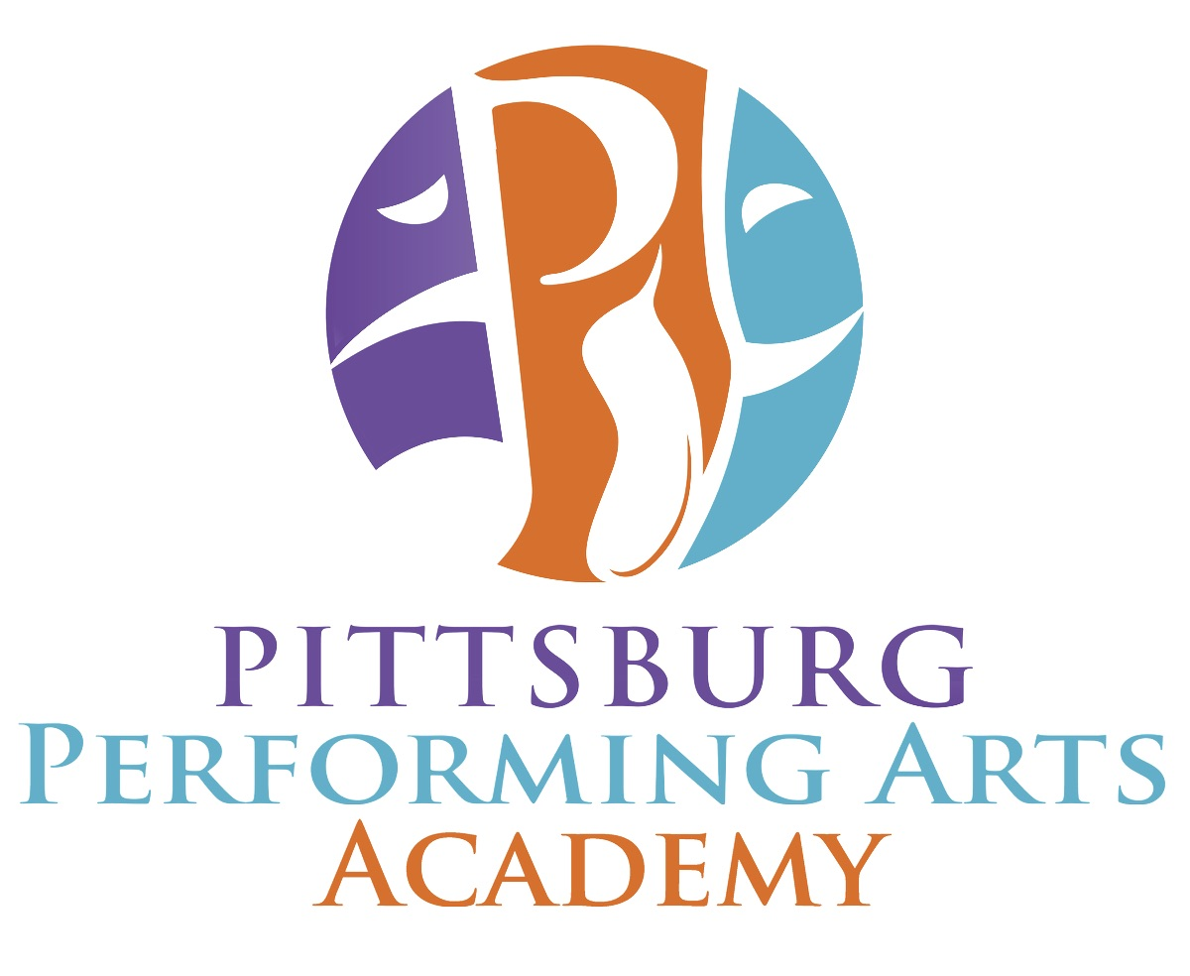
Zoom Links
Summer Session # 2

Classes run Aug 3rd – August 29th (4 weeks)
Password for all classes: PPAAsummer (case sensitive)

MONDAY
3:45 - 4:45pm Ballet 3 & 4 – MaryAnn
4:30-5:00pm Acro 1 - Sara
5:00-6:00pm Modern (Teen and Adv) - MaryAnn
5:15-6:15pm Acro 2 & 3 - Sara
6:15-7:15pm (Dance/Pointe Cond) - Amy
6:30-7:30pm Yoga - Sara
7:30-8:30pm (Ballet 5 and Teen/Adult) - Amy

TUESDAY
3:00-3:30pm Mini Ballet - Sharon
3:45 - 4:45pm Pre-Ballet - Sharon
5:00-6:00pm Ballet 1 - Sharon
6:15-7:15pm Ballet 2 - Angel
7:30-8:30pm Ballet 3/4 - Sharon

WEDNESDAY
3:00-3:30pm Mini Jazz - Natalia
3:45 - 4:45pm Elem. Lyrical/Jazz - Natalia
5:00-6:00pm Inter Lyrical/Jazz - Natalia
6:15-7:15pm Inter Hip Hop - Angel
7:30-8:30pm Ballet 5/Teen/Adult - Sharon

Saturday
*Indicates new time – different from session 1)
9:00-10:00am – Yoga - Sara
9:15-9:45 Mini Ballet - Sharon
10:15-11:15am Pre Ballet - Sharon*
10:00 -11:00am - Elem Hip Hop - Celine*
11:30-12:30pm - Ballet 1 - Sharon
11:15 -12:15pm - Inter Hip Hop - Celine*
12:45-1:45pm - Ballet 2 - Andrea*
12:30 -1:30pm - Inter Lyrical/Jazz - Celine*
2:00 -3:00pm - Ballet 3 - Andrea*

YOGA
Monday: 6:30-7:30pm Yoga - Sara
Saturday: 9:00-10:00am – Yoga - Sara

