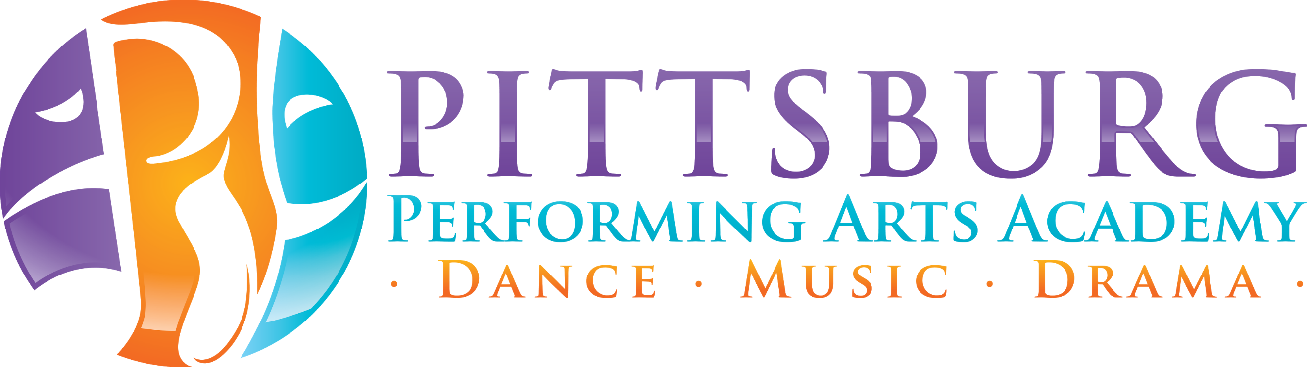
Adult Drop-in Classes
$5 per class
Please send payment via VENMO
@PittsburgPerformingArts

Schedule | Zoom Meeting ID  (Password: PPAAmoves)
Mon – 6pm Yoga w/Sara | 372-916-179
Mon – 7pm Ballet w/Amy | 838-977-302
Wed – 7:30pm Ballet w/Sharon | 817-432-081
Thurs – 6pm Ballet w/Andrea | 733-803-519
Sat– 9am Yoga w/Sara | 252-036-512

